**Information for parents and schools**

**Auditory Processing Disorder (APD)**

APD is where you have difficulty understanding sounds, including spoken words.1 APD is not a hearing problem. People with the condition usually have normal hearing.1 It is possible for a learner to have normal hearing but find it challenging to attend, listen and then understand.

The British Society of Audiology states APD

* presents as impaired perception of both non-speech and speech sounds, it is closely associated with impaired top-down, cognitive function
* There is no evidence that it is produced by a primary sensory disability
* APD may contribute to childhood learning difficulties, but its status as a distinct learning disability is controversial. Other more commonly used and agreed disorders (e.g. language impairment, dyslexia, attention deficit/hyperactivity disorder, autism spectrum disorder) should take diagnostic precedence3

If your child or learner has APD, they may find it difficult to understand:

* people speaking in noisy places
* people with strong accents or fast talkers
* similar sounding words
* spoken instructions1

There may also be difficulties with:

* music perception
* possible speech and language delay/disorder
* phonological and phonemic awareness, reading, spelling and academic difficulties

Assessment Testing for APD is not usually done on children under 7 years old.1

It is important that learners with suspected APD receive diagnosis through medical professionals to eliminate other causes of poor listening behaviour,

* other neurological diagnosis such as autism and ADHD
* hearing difficulties such as glue ear, unilateral hearing loss
* cognitive difficulties such as processing language

Suitable recommendations can then be made for such learners and can prevent inappropriate treatments that may cause harm.3

**Schools are able to seek further educational advice from their STLS District team.**

**Suggested Learning Strategies**

There is no cure for APD but there are things that can help.1 For many children, APD improves as they grow older, usually because they incorporate coping strategies into their everyday life. With reasonable adjustments, most children and young people have a successful school and work life.4

Insist on the class stopping and being quiet before giving information and instructions.

Close doors to reduce external noise. Consider partitions in open spaces.

Ask others to switch off fans and other noisy technology when not in use.

Soft furnishings, carpets and blinds reduce reverberation (sound bouncing around).

Position learner close to the speaker.

Improve the listening environment.

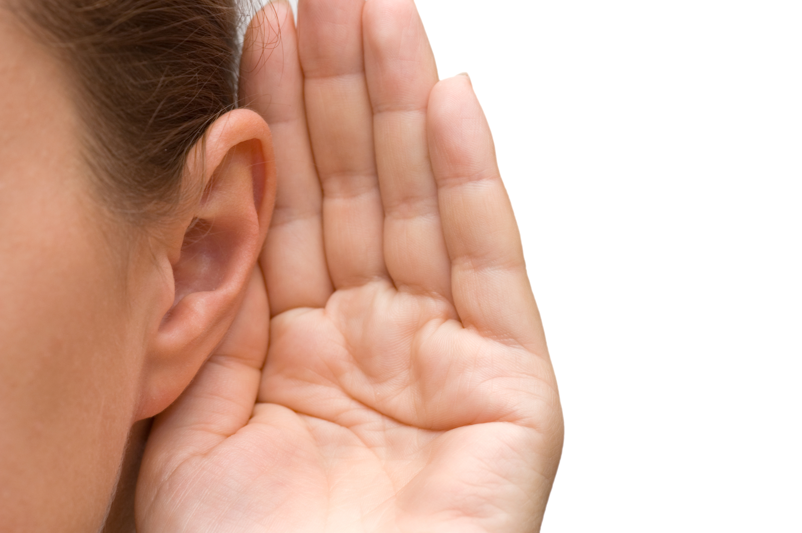



## Ensure your child / learner is attending before giving instructions, use their name to cue them in.

## Present information and instructions visually, in small steps, in the order in which they need to be completed.

* Support understanding by writing or using symbols for key words.
* Check understanding by asking the learner to explain the next step of the task.
* Teach active listening strategies and clarification techniques that support the learner to indicate when they have not understood.
* Pre teach new concepts and vocabulary the learner will encounter in the curriculum, so they are ready to engage in the lessons.
* Consider the use of productive learning breaks, review their learning when they are ready to return to the task.
* Encourage the learner to develop independent self-advocacy skills to understand what helps and to request these adjustments in a positive manner.
* Consider the use of a Soundfield system that can enhance the listening environment.**:** Connevans Ltd: Tel: 01737 247571, [www.connevans.com](http://www.connevans.com)PC Werth Ltd: Tel: 020 8772 2700, [www.pcwerth.co.uk](http://www.pcwerth.co.uk)
* Consider the use of auditory training methods [Microsoft Word - BSA_APD_Management_1Aug11_FINAL with amendments to p.30.doc (soton.ac.uk)](https://eprints.soton.ac.uk/338016/1/BSA_APD_Practice_Guidance_2011.pdf)

Use of an Assistive Listening Device may be recommended following diagnosis.

It is crucial that an audiologist, ahead of any consideration of personal assistive listening technology, evaluates a child’s hearing and middle ear function to rule out hearing loss and any problems requiring audiological intervention, or onward medical referral. APD technology is not a substitute for other intervention that may be required, e.g. speech and language support or learning support. A trial with any personal assistive listening technology is advised before final fitting to ensure benefit and acceptance. For some children extra technology can be a distractor. For others cosmetic considerations may play a role.3

The Mainstream Core Standards provide advice to school for learners with a wide variety of needs. [The Mainstream Core Standards - KELSI](https://www.kelsi.org.uk/special-education-needs/special-educational-needs/the-mainstream-core-standards#:~:text=The%20Mainstream%20Core%20Standards%20-%20KELSI%20The%20Mainstream,Special%20Educational%20Needs%20and%2For%20disabilities%20attending%20mainstream%20schools.)