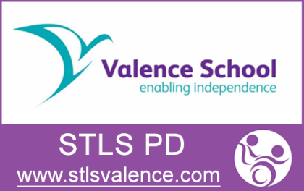
Course descriptors
STLS PD core training offer
2020-21

Fine motor skills, developing handwriting and alternative methods of recording the curriculum – cost £37 – book via www.stlsvalence.com
- This course is aimed at KS1-KS2 teachers and SENDCos.
- This 3 hour course will look at support for CYP with handwriting difficulties. It will cover:
- Strategies and activities for fine motor skills development
- Resources and strategies for children who need additional help with writing
- Alternative methods and resources to help differentiate the curriculum for recording
- Introduction to use of assistive technology for CYP with handwriting difficulties

Alternative methods of recording the curriculum and use of assistive technology for CYP who have handwriting difficulties – cost £37 – book via www.stlsvalence.com
- This course is aimed at KS2 – KS4 teachers and SENDCos
- 3 hour course will look at support for CYP with handwriting difficulties. It will cover:
- Resources and strategies to support alternative ways of recording paper-based evidence
- Assistive technology solutions for CYP with handwriting difficulties using computer software that should be readily available in schools
- Advice on JCQ requirements for exam arrangements

Introduction to paediatric moving and handling in schools – cost £50 – book via www.stlsvalence.com
- A generic course covering theory and practical hand-on training for all staff working with PD or complex medical needs children and young people
- 6 hours course with lunch break (9:30-3:30)
- Course content: Legislation – duties and responsibilities
- Back awareness and back care, biomechanics of the body
- Safer principles of manual moving and handling and introduction to hoisting
- Risk assessments for moving and handling PD and/or complex medical needs

Refresher course for paediatric moving and handling in schools – cost £37 – book via www.stlsvalence.com
- This course is aimed at staff working with PD or complex medical needs children and young people who have attended a generic paediatric moving and handling course within the last 2 years (evidence will be required)
- 3 hours course with revisits relevant legislation: duties and responsibilities
- Review of safer principles of manual moving and handling
- Review of principles of hoisting and safety checks
- Review of risk assessments and personal care agreements
- workshop discussion around problem solving real situations

PD and PE! – cost £250 (3 hours half day) or £300 (2 x 90 minute twilight)
- We are offering a workshop (or 2 twilights) for school clusters (up to 20 staff) or multi-academy trusts. Training packages can be arranged for half day or two twilight sessions at one of the schools organising the group. We are offering one primary focused workshop and one secondary.
Contact: stlspd@valence.kent.sch.uk to discuss dates and arrangements

- Workshops will be practical with lots of discussion and interaction to focus on solution focused problem solving for pupils currently known to staff attending the workshop.
- CONTENT
  - Curriculum overview
  - What is inclusive PE?
  - Possible barriers to participation
  - Knowing your students
  - Differentiation for inclusion
  - Equipment ideas to support inclusion
  - Safety
  - Changing
  - Sports Day
  - Secondary – Examination Courses

